Open Irregular Polygonal Shape
# Source: AI Source: Provided by: [Data Path: Persons Table -> ID Column: 1, Name_En Column: Motasem Essam] -> From: [ChatGPT] on [7/25/2026]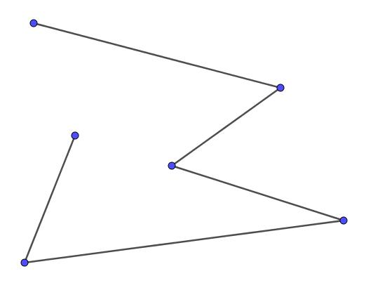
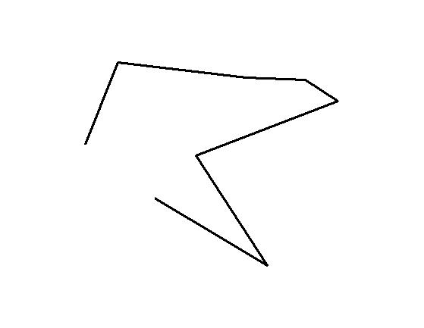

Definition
# Source: AI Source: Provided by: [Data Path: Persons Table -> ID Column: 1, Name_En Column: Motasem Essam] -> From: [ChatGPT] on [7/25/2026]
An Open Irregular Polygonal Shape is an open geometric figure made from three or more straight line segments connected end-to-end, where the segments and angles do not follow a regular pattern and the final endpoint does not connect to the starting point.
$$\boxed{\text{Open Irregular Polygonal Shape}=\text{Multiple Straight Segments}+\text{Irregular Arrangement}+\text{Open Boundary}}$$
Terminology note: In strict mathematical terminology, an open figure made of line segments is better described as an open polygonal path, because a polygon is normally closed. The term Open Irregular Polygonal Shape is useful within your classification system.

Characteristics
# Source: AI Source: Provided by: [Data Path: Persons Table -> ID Column: 1, Name_En Column: Motasem Essam] -> From: [ChatGPT] on [7/25/2026]
An Open Irregular Polygonal Shape:
- Is open.
- Contains three or more straight line segments.
- Has connected consecutive segments.
- Has two unconnected endpoints.
- Does not enclose an area.
- Usually has unequal segment lengths.
- May have different angles at its vertices.
- Does not have a regular repeating pattern.
- May be symmetric or asymmetric.
- May be simple or self-intersecting.

Types of Open Irregular Polygonal Shapes

1. Simple Open Irregular Polygonal Shape
# Source: AI Source: Provided by: [Data Path: Persons Table -> ID Column: 1, Name_En Column: Motasem Essam] -> From: [ChatGPT] on [7/25/2026]
A general open polygonal path with unequal segments and irregular angles, without self-intersection.
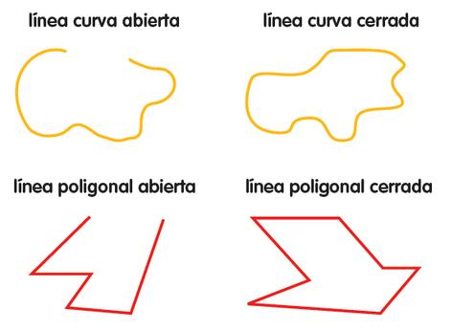

2. Open Irregular Zigzag Shape
# Source: AI Source: Provided by: [Data Path: Persons Table -> ID Column: 1, Name_En Column: Motasem Essam] -> From: [ChatGPT] on [7/25/2026]
A polygonal path with repeated but irregular changes in direction.
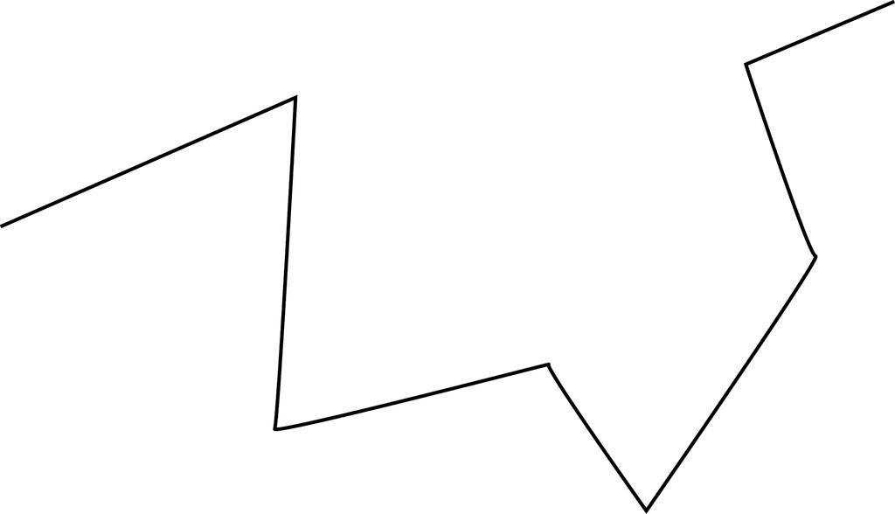
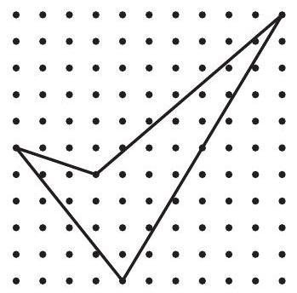
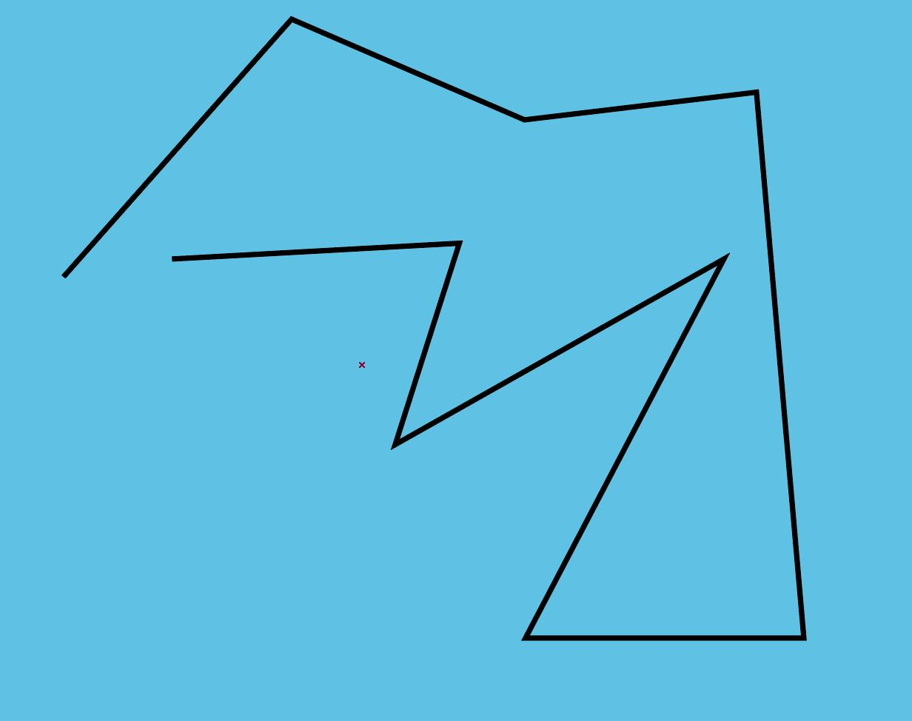
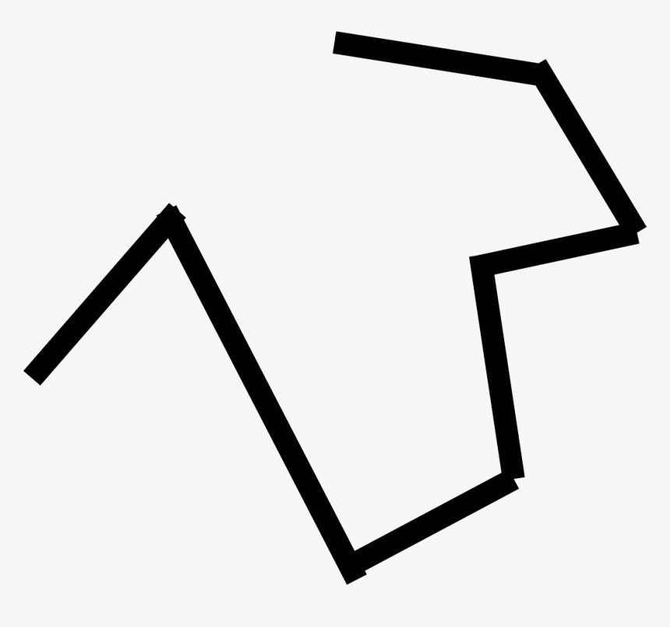
The segment lengths and turning angles do not need to be equal.

3. Open Irregular Stair-Step Shape
# Source: AI Source: Provided by: [Data Path: Persons Table -> ID Column: 1, Name_En Column: Motasem Essam] -> From: [ChatGPT] on [7/25/2026]
A step-like open path consisting of horizontal and vertical segments with unequal dimensions.
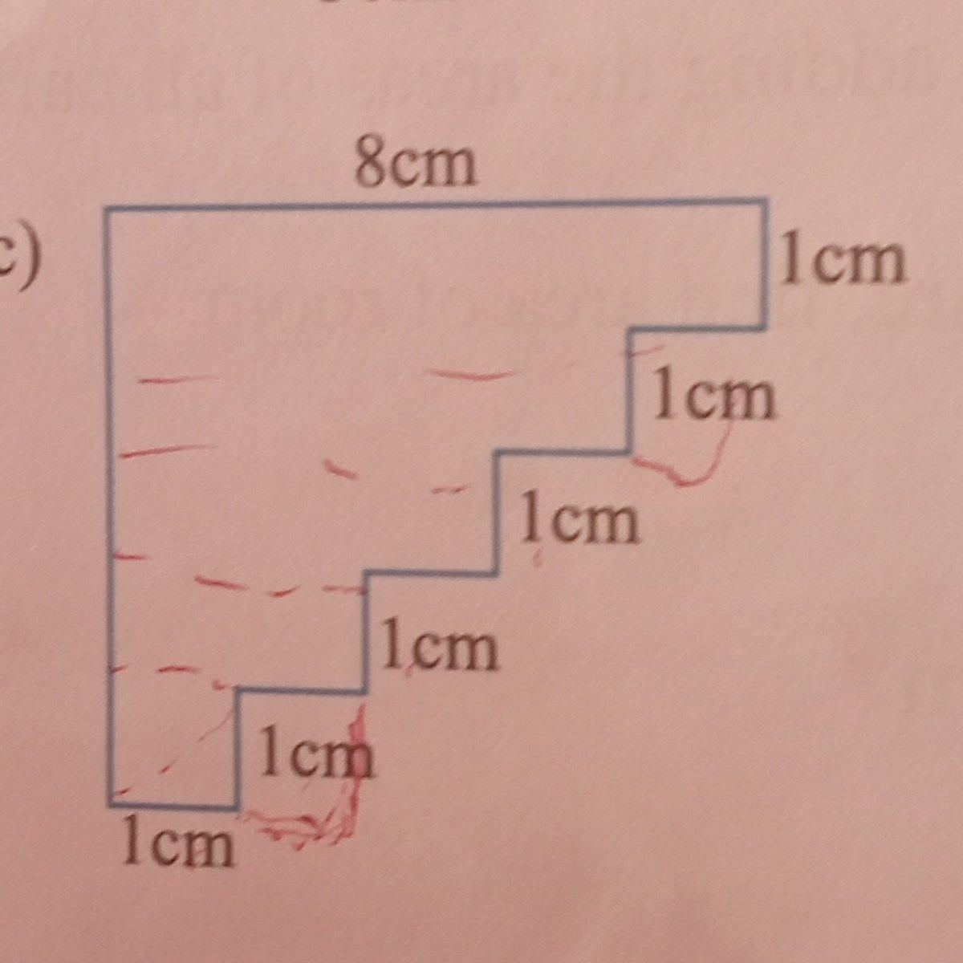
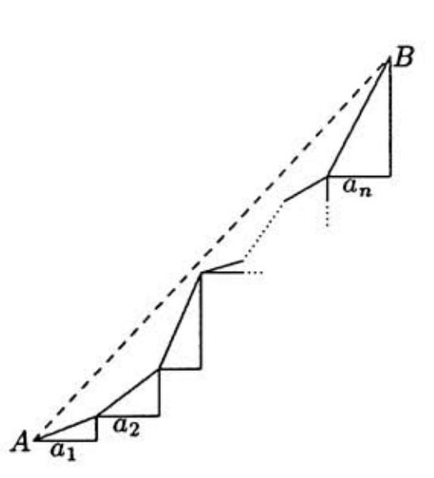
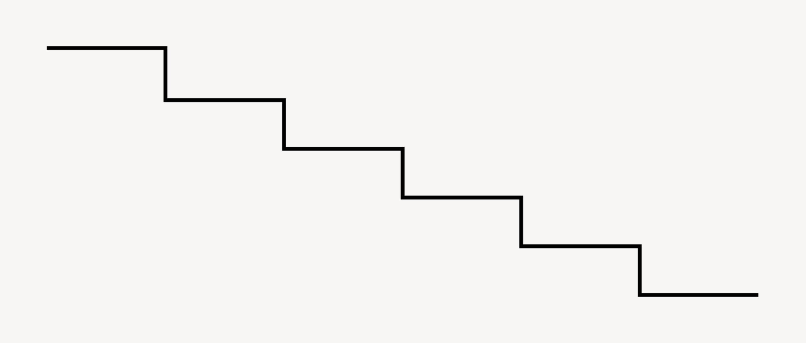

4. Open Irregular Varying-Angle Shape
# Source: AI Source: Provided by: [Data Path: Persons Table -> ID Column: 1, Name_En Column: Motasem Essam] -> From: [ChatGPT] on [7/25/2026]
The path contains vertices with different angle measures.
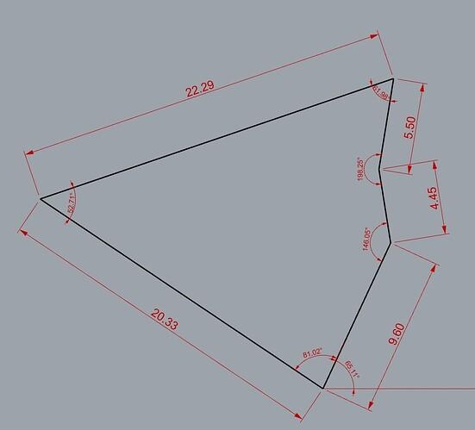
For example:
[
\theta_1\neq\theta_2\neq\theta_3
]

5. Open Irregular Unequal-Segment Shape
# Source: AI Source: Provided by: [Data Path: Persons Table -> ID Column: 1, Name_En Column: Motasem Essam] -> From: [ChatGPT] on [7/25/2026]
The defining characteristic is that the straight segments have different lengths.
$$\boxed{L_{1}≠L_{2}≠L_{3}≠⋯}$$
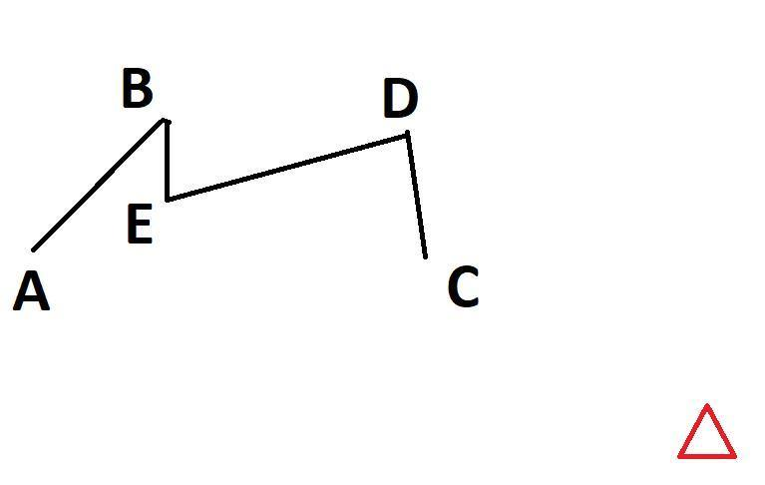
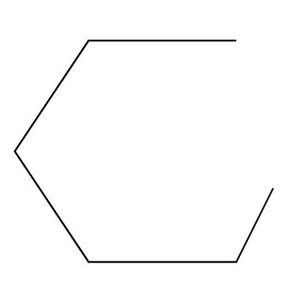

6. Open Irregular Asymmetric Polygonal Shape
# Source: AI Source: Provided by: [Data Path: Persons Table -> ID Column: 1, Name_En Column: Motasem Essam] -> From: [ChatGPT] on [7/25/2026]
The segments and vertices are arranged without reflection symmetry.

7. Open Irregular Self-Intersecting Shape
# Source: AI Source: Provided by: [Data Path: Persons Table -> ID Column: 1, Name_En Column: Motasem Essam] -> From: [ChatGPT] on [7/25/2026]
Some segments cross one another while the overall path remains open.
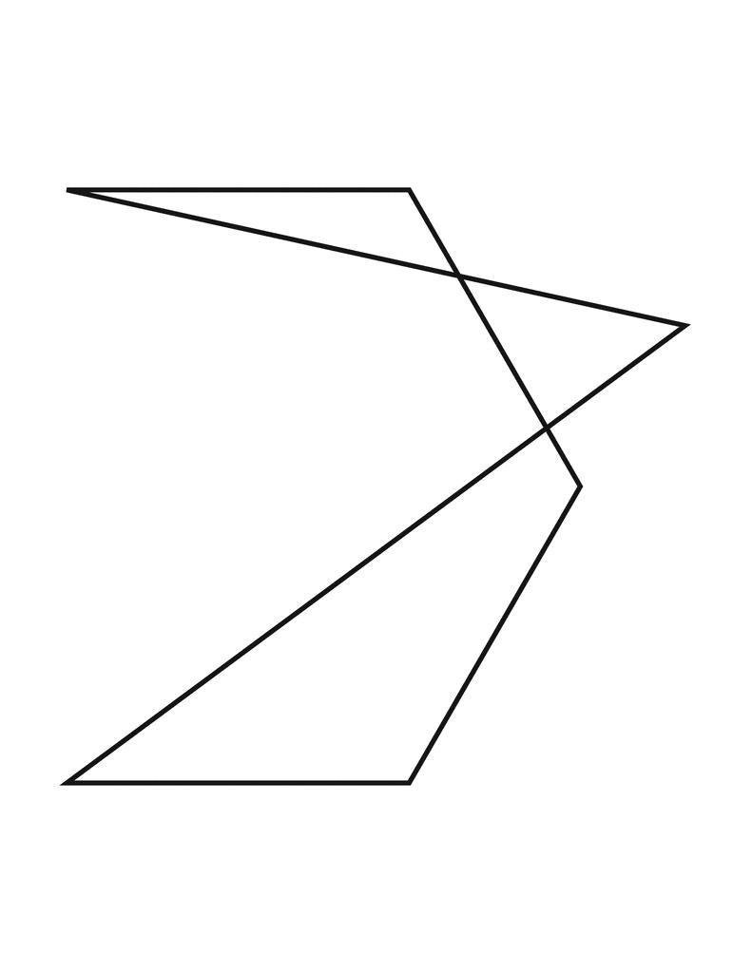
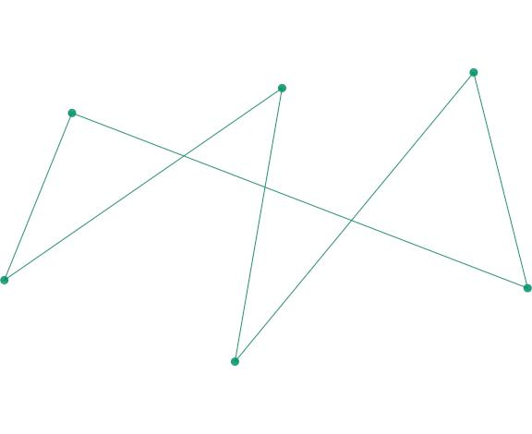
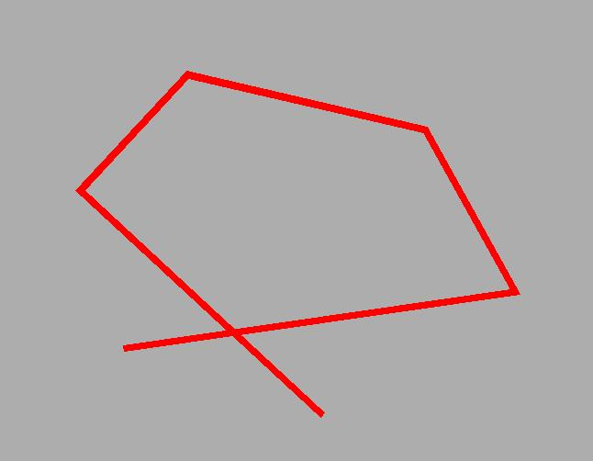
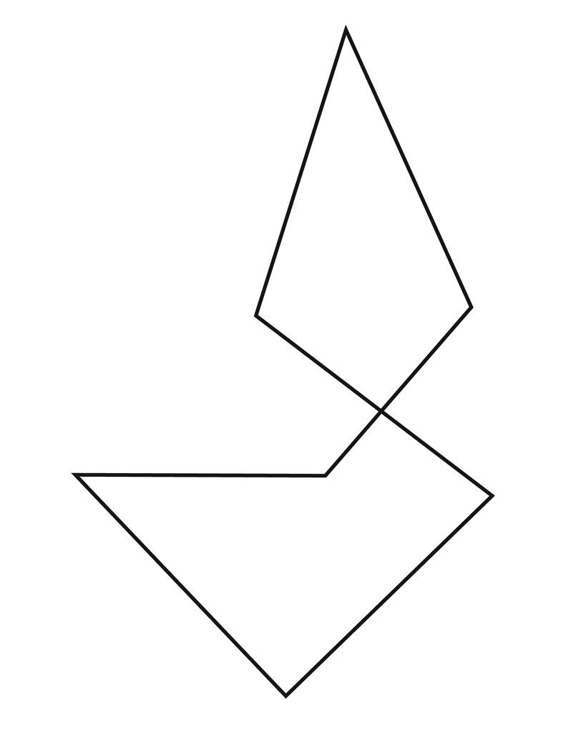
The intersections do not make the figure closed.

8. Open Irregular Branch-Like Polygonal Shape
# Source: AI Source: Provided by: [Data Path: Persons Table -> ID Column: 1, Name_En Column: Motasem Essam] -> From: [ChatGPT] on [7/25/2026]
The main path follows irregular directions and can include connected branch-like segments.
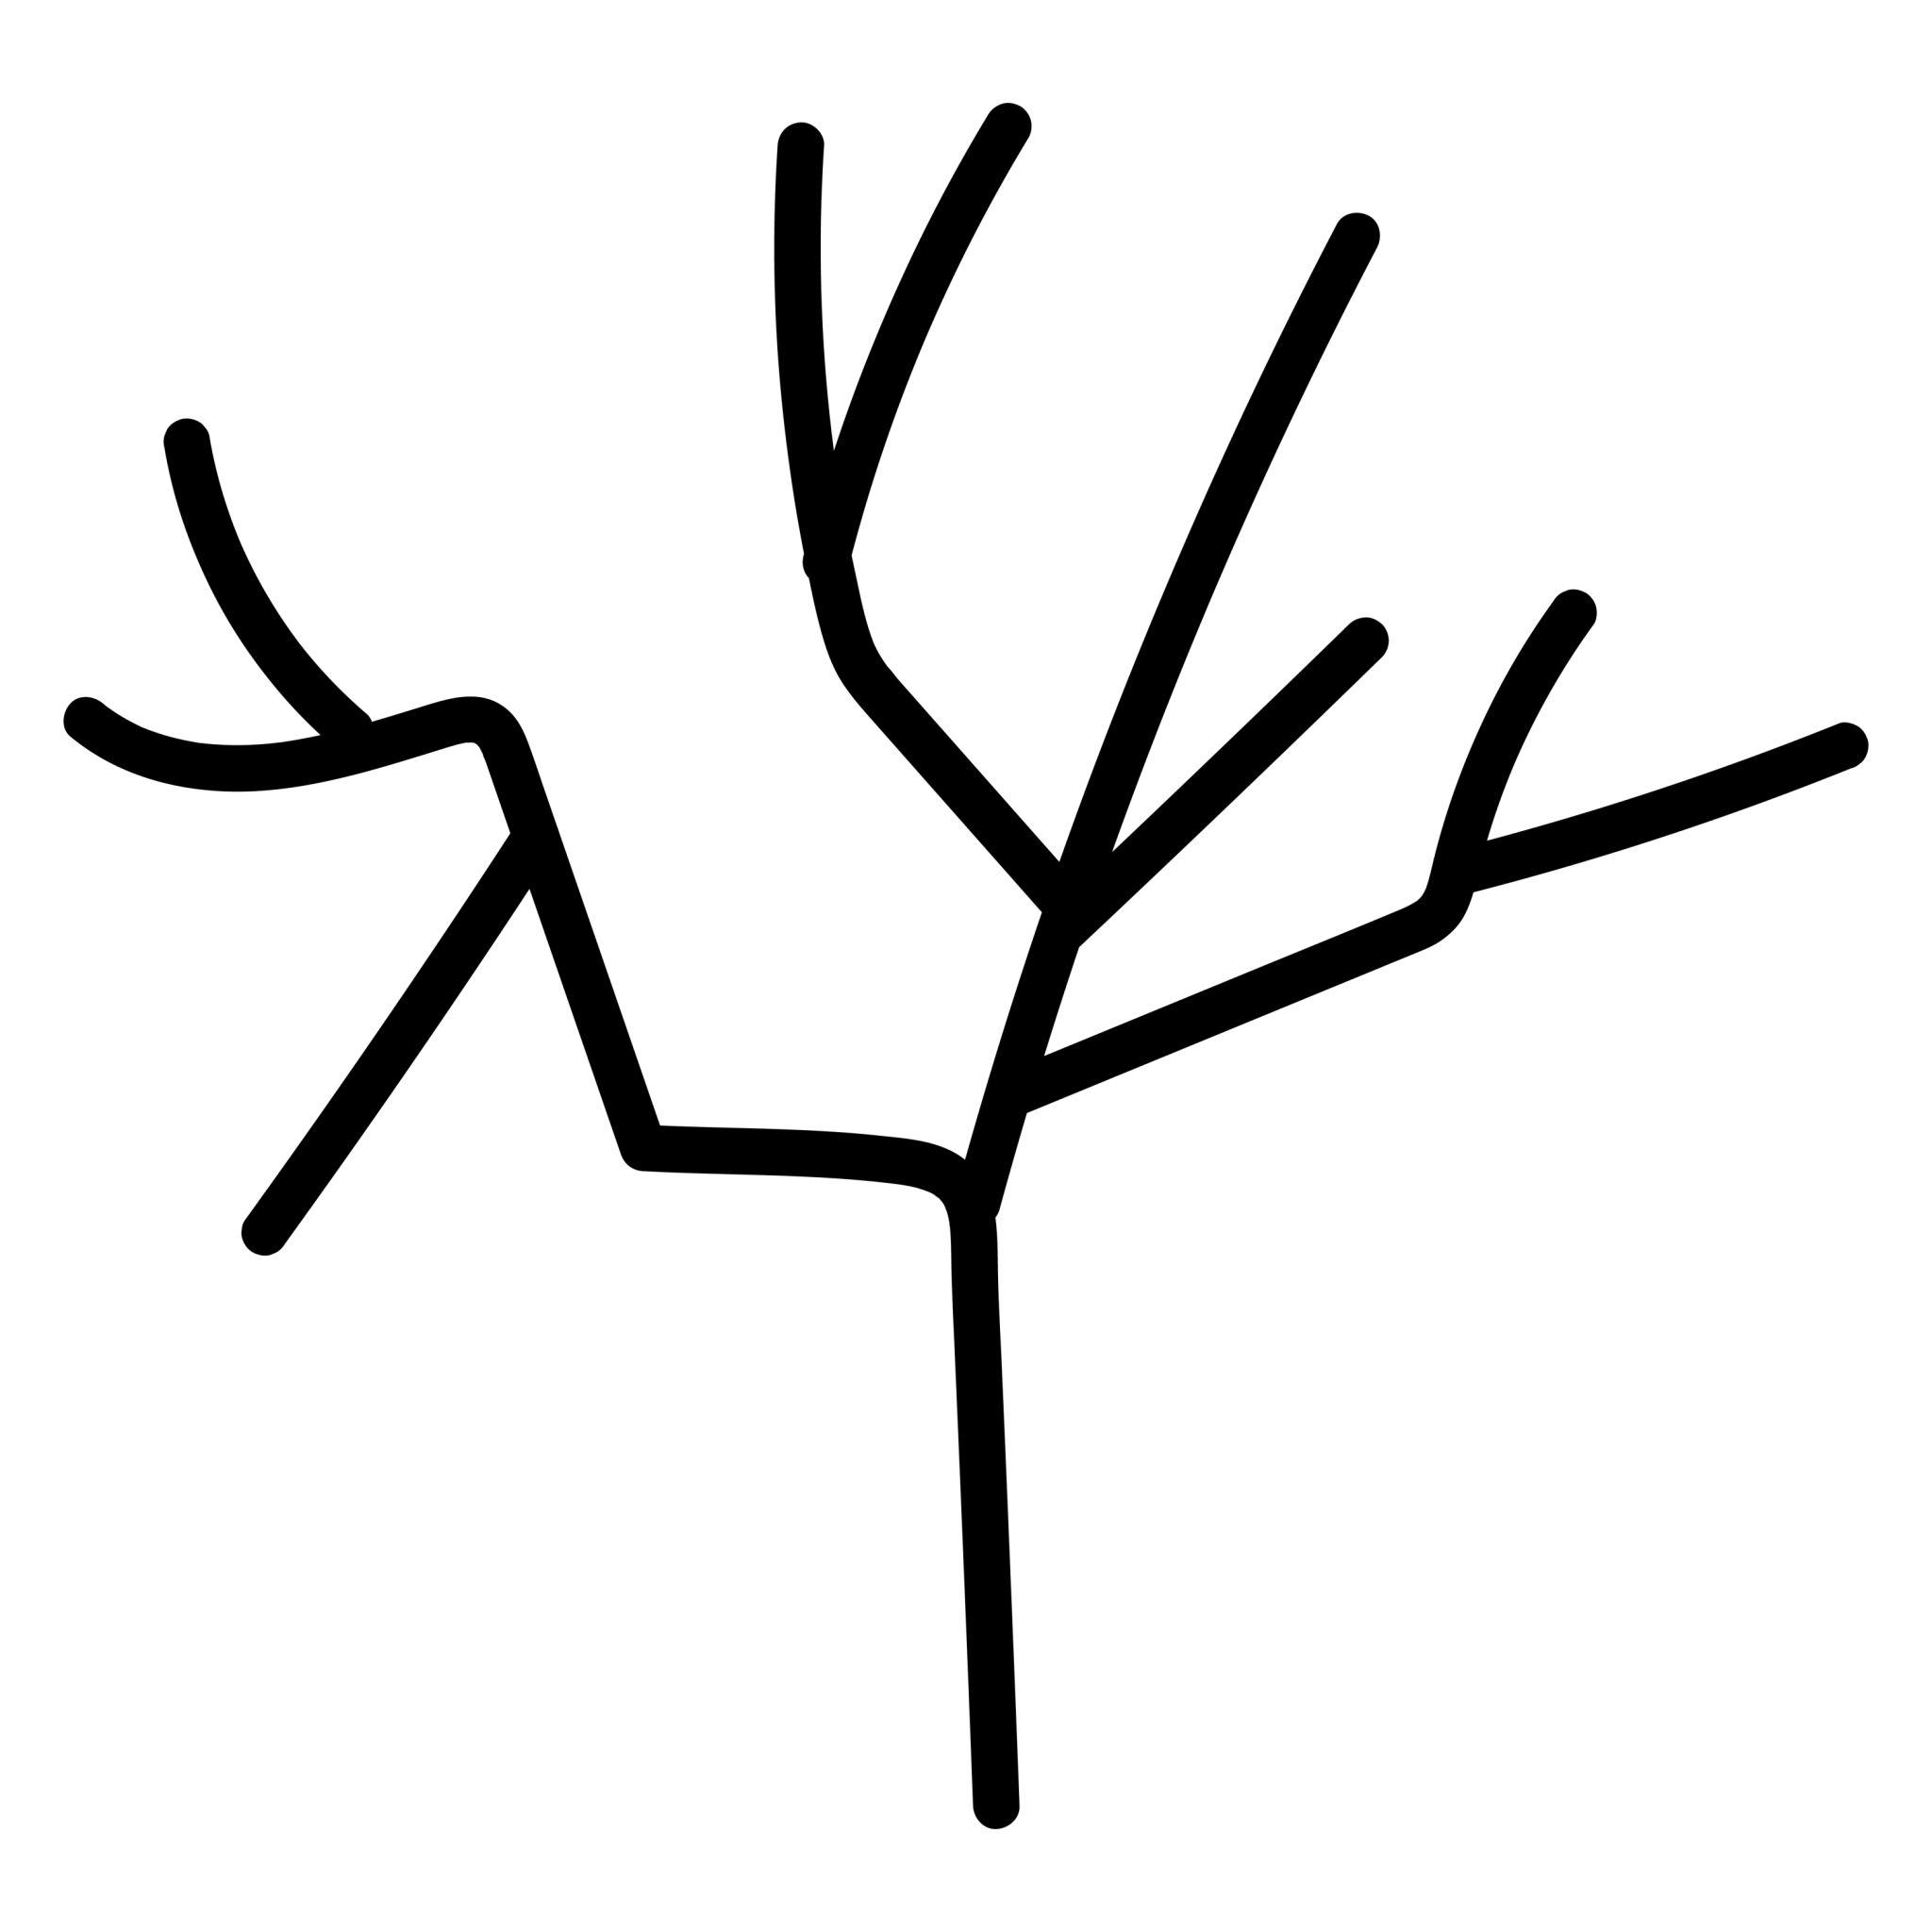
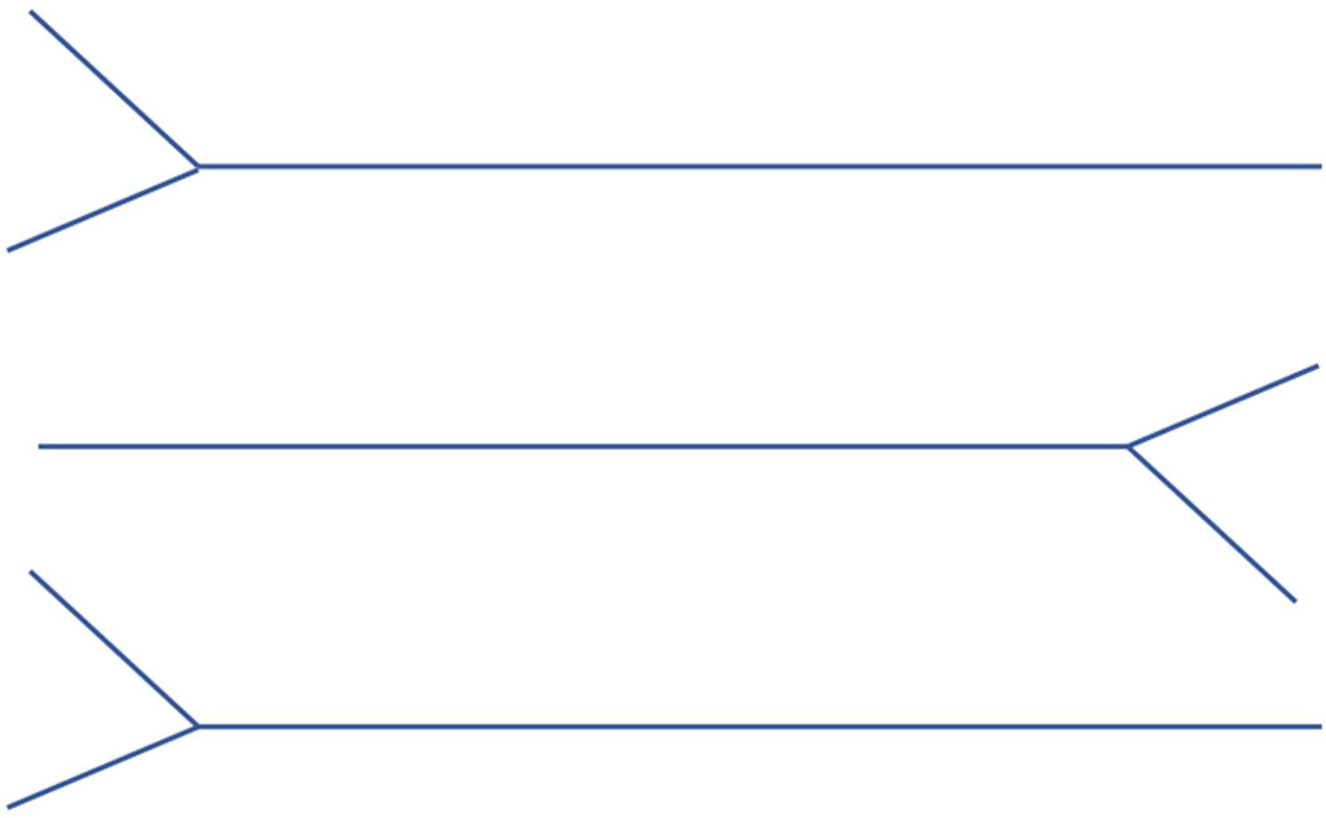
If branches are included, it is more accurately described as an open polygonal network rather than a single polygonal path.

9. Open Irregular Multi-Directional Shape
# Source: AI Source: Provided by: [Data Path: Persons Table -> ID Column: 1, Name_En Column: Motasem Essam] -> From: [ChatGPT] on [7/25/2026]
The segments change direction in several different orientations.
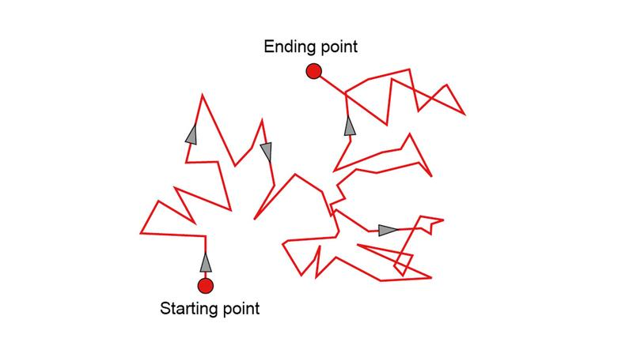
There is no requirement that the segments be horizontal, vertical, or diagonal in a particular pattern.

10. Open Irregular Random-Like Polygonal Shape
# Source: AI Source: Provided by: [Data Path: Persons Table -> ID Column: 1, Name_En Column: Motasem Essam] -> From: [ChatGPT] on [7/25/2026]
The segments are arranged with apparently arbitrary lengths and directions.
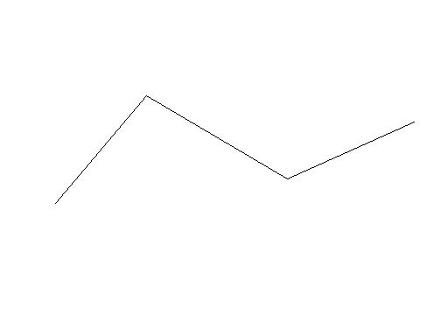
This is useful as a general category for irregular open polygonal paths that do not fit a more specific pattern.

Open Irregular vs. Open Regular Polygonal Shapes
# Source: AI Source: Provided by: [Data Path: Persons Table -> ID Column: 1, Name_En Column: Motasem Essam] -> From: [ChatGPT] on [7/25/2026]
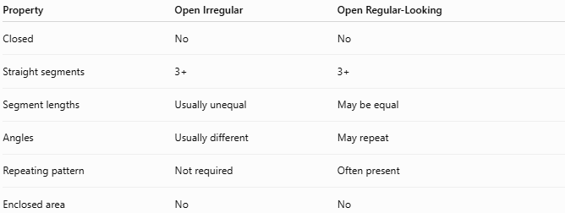
Property | Open Irregular | Open Regular-Looking
Closed | No | No
Straight segments | 3+ | 3+
Segment lengths | Usually unequal | May be equal
Angles | Usually different | May repeat
Repeating pattern | Not required | Often present
Enclosed area | No | No
The most important distinction is irregularity, not simply the fact that the shape is open.

Open Irregular Polygonal Shape vs. Open Zigzag Shape
# Source: AI Source: Provided by: [Data Path: Persons Table -> ID Column: 1, Name_En Column: Motasem Essam] -> From: [ChatGPT] on [7/25/2026]
These categories overlap.
Open Zigzag describes the pattern of direction changes.
Open Irregular Polygonal describes the lack of regularity in the segments and angles.
Therefore, a shape can be both:
$$\boxed{\text{Open Irregular}+\text{Zigzag}}$$
For example, an unequal zigzag path with varying angles is an Open Irregular Zigzag Polygonal Shape.

Area and Length
# Source: AI Source: Provided by: [Data Path: Persons Table -> ID Column: 1, Name_En Column: Motasem Essam] -> From: [ChatGPT] on [7/25/2026]
Area
Because the shape is open, it does not enclose a region:
$$\boxed{A=\text{no enclosed area}}$$
Total Length
If the path contains $n$ segments:
$$\boxed{L=\sum_{i=1}^{n}{L_{i}}}$$
or:
$$L=L_{1}+L_{2}+⋯+L_{n}$$

Key Points
# Source: AI Source: Provided by: [Data Path: Persons Table -> ID Column: 1, Name_En Column: Motasem Essam] -> From: [ChatGPT] on [7/25/2026]
An Open Irregular Polygonal Shape is:
$$\boxed{\text{Open}+\text{3 or More Straight Segments}+\text{Irregular Arrangement}}$$
It:
- Has three or more straight segments.
- Has two open endpoints.
- Does not enclose an area.
- Usually has unequal segment lengths.
- Usually has varying angles.
- Does not follow a regular repeating pattern.
- Can be zigzag, stair-step, asymmetric, or multi-directional.
- May be simple or self-intersecting.
- Is more precisely called an open irregular polygonal path in formal geometry.
Most important distinction
$$\boxed{\text{Open Irregular Polygonal Shape}≠\text{Closed Irregular Polygon}}$$
The first is an open path, while the second encloses a region.

Conclusion
# Source: AI Source: Provided by: [Data Path: Persons Table -> ID Column: 1, Name_En Column: Motasem Essam] -> From: [ChatGPT] on [7/25/2026]
Open Irregular Polygonal Shapes are open figures made from three or more straight line segments arranged irregularly. Their endpoints remain unconnected, so they do not enclose an area. They can be further classified by their segment lengths, angle patterns, direction changes, symmetry, and self-intersection behavior.

